Given a root of an N-ary tree, you need to compute the length of the diameter of the tree.

The diameter of an N-ary tree is the length of the **longest** path between any two nodes in the tree. This path may or may not pass through the root.

(*Nary-Tree input serialization is represented in their level order traversal, each group of children is separated by the null value.)*

**Example 1:**

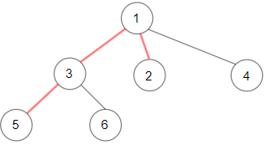

Input: root = [1,null,3,2,4,null,5,6]  
Output: 3  
Explanation: Diameter is shown in red color.

**Example 2:**

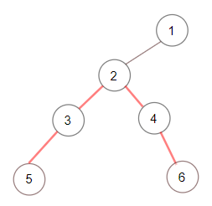

Input: root = [1,null,2,null,3,4,null,5,null,6]  
Output: 4

**Example 3:**

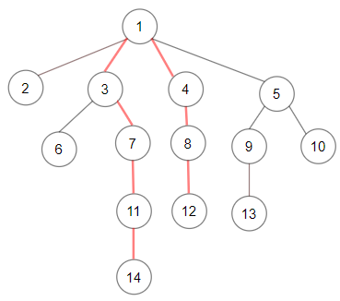

Input: root = [1,null,2,3,4,5,null,null,6,7,null,8,null,9,10,null,null,11,null,12,null,13,null,null,14]  
Output: 7

**Constraints:**

* The depth of the n-ary tree is less than or equal to 1000.
* The total number of nodes is between [1, 104].